16

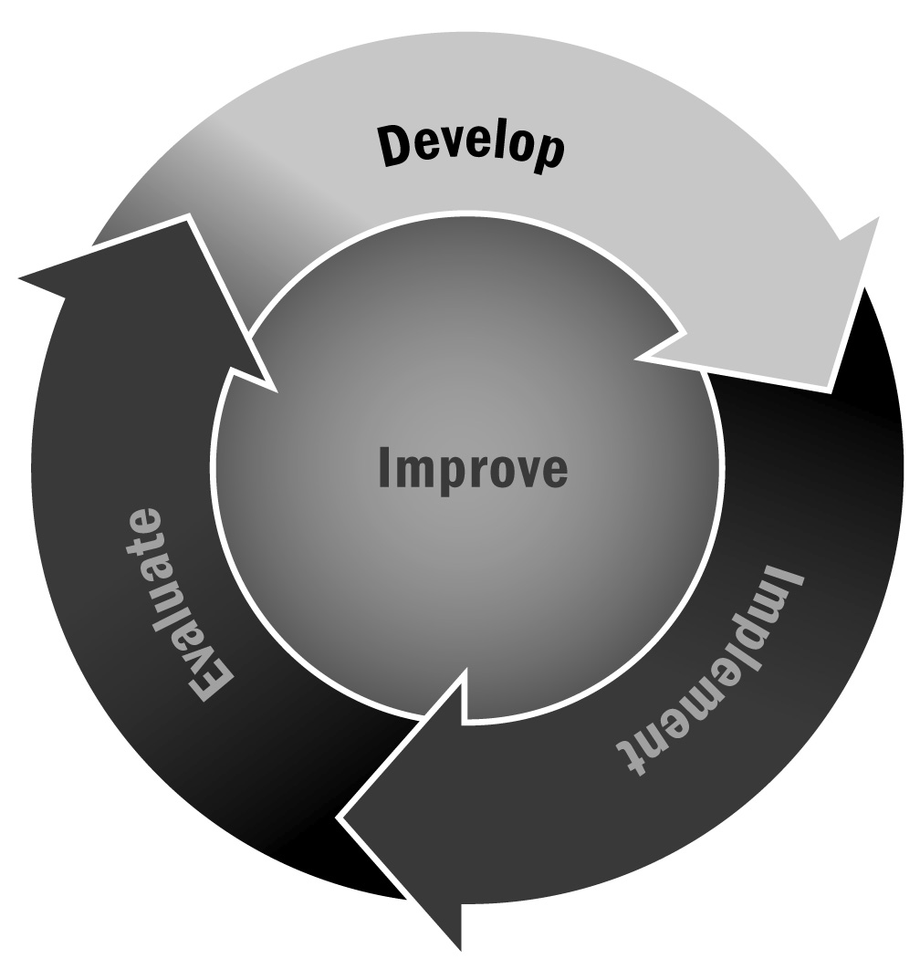
Grant-Writing Tips
In Chapter 1, you learned that grants are probably the most common type of funding for afterschool and expanded learning programs. These come from both local and national sources and can be both public and private. Writing a grant is not an easy task, nor is it one to rush through. Taking the time to research the funder and carefully explore each opportunity will pay off.
Directions: Use the following tips for successful grant writing.

Do | Don’t
- Make sure you are eligible. Read the entire grant application to make sure it is right for the afterschool and expanded learning program you have or have in mind. |  | - Don’t try to “fit” your program to a grant if it is not a natural match. Chances are your application won’t be competitive.
- Follow all instructions for page limits, font requirements, spacing, appendices, and other specifications. |  | - Don’t exceed the page limit recommendation for your proposal’s narrative text or get too creative with fonts and margins to give yourself more room. Such actions may hinder your chances of getting the grant.  - Don’t add additional appendices to include more information unless the instructions indicate that this is allowed.
- Make sure you organize the grant narrative to address explicitly any stated selection criteria. If criteria are presented, your grant will probably be rated on how well you address these criteria. Often, the instructions will indicate what sections should be included in the narrative. |  | - Don’t be vague about goals, objectives, and intended outcomes in the narrative.
- Make sure you address each item the grant asks for in the narrative, appendices, and additional forms and assurances. Create a checklist of required elements and check them off as you address them in the application.  - Make it easy for the reviewer to “check off” each requirement without having to hunt for information. |  | - Don’t forget to include critical information required on forms and any other assurances necessary.
- Ask for enough funding, based on what the grant provides or recommends. |  | - Don’t ask for an inflated amount of funding, especially if you are seeking funding for only one site.
- Write clearly for the reviewers, providing specifics about your program and community. Use headers, keep your sentences short, and organize your text into paragraphs. |  | - Don’t assume that the readers know anything in advance about your community or program.
- Proofread the proposal! Have someone else (someone not involved in the process) read your grant. | - Don’t assume that the writing is error free.  - Don’t rely on computer spell checks and grammar checks. They don’t find all the errors.
- Provide a budget for each year for the amount you are requesting from the funder. Be careful to review any matching requirements and make sure you can meet them. If budget forms are required (federal grants require them), make sure you fill them out completely. Check your math! | - Don’t assume the readers will know what you “meant” to say if you make a mistake. If you mistakenly ask for less money than your budget details, you may be awarded only the lower amount (if you get an award at all).  - Don’t use your own budget forms if specific budget forms are required.
- Follow the application’s instructions for submission. The instructions may ask you to submit both electronic and paper copies of the application.  - Make sure you are familiar with any online submission system well before the due date.  - Sign your paper version of the application in blue ink and submit the required number of copies. | - Don’t wait until the last minute to submit an electronic version of your application in case there are issues with the online system.  - If you are posting paper copies, make sure you leave enough time for them to reach the location by the due date.  - Don’t submit additional material after you have already sent in your application. It may not be considered in the review process.

